**STP - DOCUMENT**

Movie website

By: Aya motlk

3/7/2023

Contents

Introduction 3

Objectives 3

Scope 4

Testing Approach 4

Test Environment 4

Test Plan 4

Test Cases 5

Test Results 5

Test strategy 5

Out of scope 6

Testing methodology 6

Validation and Defect Management 7

Defect tracking & Reporting 7

Status of the Bug/Fault 8

Conclusion 8

**STP-** **Software Test Plan**

**Version: 1.0**

**Created: 12/01/2023**

**Last Updated: 28/01/2023**

**Test Plan Template: Flask application MOVIES**

**Prepared by: Aya Moutlk**

# Introduction

The purpose of this Software Test Plan (STP) document is to provide a comprehensive testing approach and strategy for the "Movies Website" project. The website will be developed will provide users with access to movies pages and info about the movie.

## Objectives

This test plan describes the testing approach, the objectives, scope, schedule, risks, approach, Enter & Exit criteria, Test Tree and Testing methodology. and overall framework that will drive the testing.

The objectives of the testing effort for the Movies Website project are:

* To ensure that the website is functional and user-friendly
* To verify that the website meets all specified requirements
* To identify and report any defects or issues found during testing
* To complete testing within the specified timeline and budget
* To ensure that the website is scalable and maintainable

Support documents: SRS

## Scope

The scope of the testing effort for the Movies Website project includes:

* Functional testing of all pages and features of the website
* Non-functional testing, including usability, performance, security, and compatibility testing
* Regression testing of any defects or issues found during testing
* Acceptance testing to ensure that the website meets the expectations of the stakeholders.

# Testing Approach

The testing approach for the Movies Website project includes:

A combination of manual and automated testing

Testing will be performed in multiple phases (unit testing, integration testing, system testing, and acceptance testing)

Black-box and white-box testing techniques will be used

The website will be tested using different browsers and operating systems

## Test Environment

The test environment for the Movies Website project includes:

Operating System: Windows 10

Browsers: Google Chrome (selenium and automation test), Microsoft Edge.

## Test Plan

The test plan for the Movies Website project includes:

* Unit Testing: Testing of individual components/modules of the website will be performed by tester.
* Integration Testing: Testing of the integration between different modules of the website will be performed by tester.
* System Testing: End-to-end testing of the entire website will be performed by tester.
* Acceptance Testing: Testing of the website from the user's perspective will be performed by testers and stakeholders.

Each testing phase will be performed according to the specified schedule and resources

## Test Cases

The test cases for the Movies Website project include:

Functional Test Cases: Test cases that cover all functional requirements of the website will be developed and executed.

Non-Functional Test Cases: Test cases that cover non-functional requirements such as usability, performance will be developed and executed.

Test cases will be designed to cover all possible scenarios and edge cases.

## Test Results

The test results for the Movies Website project will be documented as follows:

Defects and issues found during testing will be recorded in a defect tracking tool

The severity of each defect and issue will be assigned

The steps to reproduce each defect and issue will be documented

The status of each defect and issue (open, resolved, closed) will be updated as necessary.

## Test strategy

Test Approach: The tests mainly target the GUI testing and validating data Requirements Specifications provided by Client. The project is using an agile approach, with iterations.

Test Automation: Automated unit tests are part of the development process, They part from test automated functional tests in part 5 from this HW.

Exploratory: Purpose: the purpose of this test is to make sure critical defects are removed before the next levels of testing can start.

Scope: Signup, Send message and mobile version.

Testers: Testing team.

Method: Testing is carried manual and automation.

User Acceptance Test: Purpose: This test focuses on validating the business logic.

Testes: Client-side testers.

Timing: After all other levels of testing (Exploratory and Functional) are done.

Functional Test: purpose: The functional testing is carried out by feeding the input and validates the output from the application.

Testers: Testing Team.

Methods: The test will be performed according to Functional scripts, which are stored in test rail.

Timing: After Exploratory test is completed.

## Out of scope

Purpose: Clarity on what we are not going to cover.

Not in Scope: Testing of Business SOPs, disaster recovery

## Testing methodology

Validation and Defect Management: Defects found during the Testing will be categorized according to the bug-reporting tool “Jira”

## Validation and Defect Management

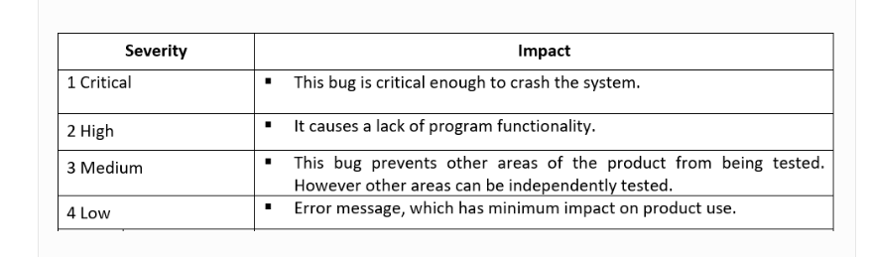

## Defect tracking & Reporting

Flowchart depicts Defect Tracking Process

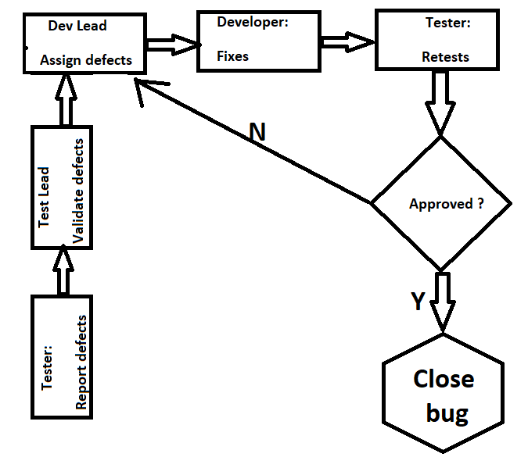

## Status of the Bug/Fault

- New: Just created bug;

- Open: Opened bug and still not solved;

- Rejected: Dev Lead rejected it (it's not bug);

- Fixed: Solved bug;

- Closed: After bug is fixed, need close this bug;

- Re-Open: Bug was been fixed and closed but appear again with time.

# Conclusion

In conclusion, the testing approach and strategy outlined in this STP document will ensure that the Movies Website project meets all specified requirements and is functional, user-friendly, and scalable. (All stakeholders have reviewed and approved this STP document, and testing will begin according to the specified schedule and resources.)